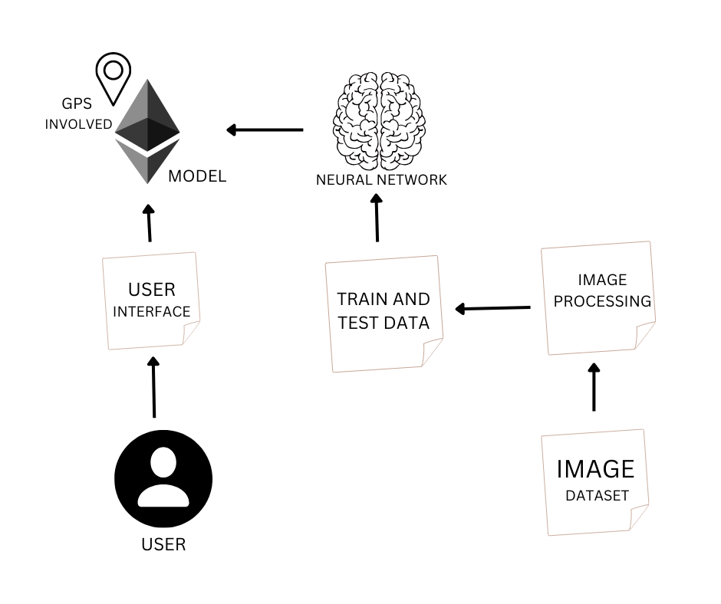**FIRST MILESTONE**

PROJECT THEME:

* A clear learned knowledge of neural networks must be there in implementing the project.
* This project is based on image processing and voice recognition.
* First a train dataset and test dataset are uploaded in the image set.
* Once the user asks to recognized the data in front of them, the object is detected at particular distance.
* Then they are sensed by the user interface thus get transferred to the project model to be sensed.
* Then the data is compared with the dataset in the convolutional neural networks.
* Then required output is given in vocal form to the user.